Flink Monitoring

1. Configuring Prometheus with Flink

* To start monitoring Flink with Prometheus, the following steps are necessary

1. Make the PrometheusReporter jar available to the classpath of the Flink cluster (it comes with the Flink distribution)

cp ./flink-metrics-prometheus-1.12.4.jar /opt/flink/lib

1. Configure the reporter in Flink’s flink-conf.yaml. All job managers and task managers will expose the metrics on the configured port

metrics.reporters: prom

metrics.reporter.prom.class: org.apache.flink.metrics.prometheus.PrometheusReporter

metrics.reporter.prom.port: 9999

1. For receiving Flink Cluster metrics

Add to jobmanager-service.yaml and taskmanager-service.yaml

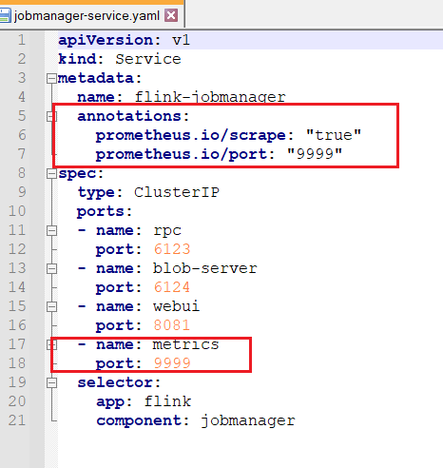

Add to jobmanager-session-deployment.yaml and taskmanager-session-deployment.yaml

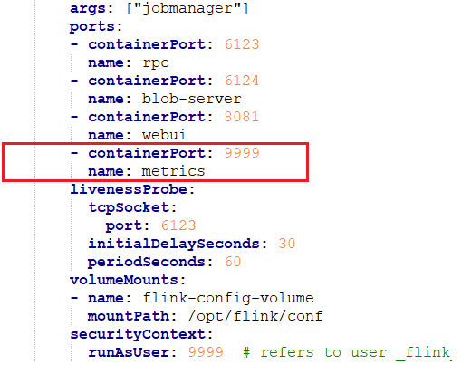

1. Access to Prometheus and Grafana (Available in istio)

* Prometheus

kubectl port-forward service/prometheus 9999:9090

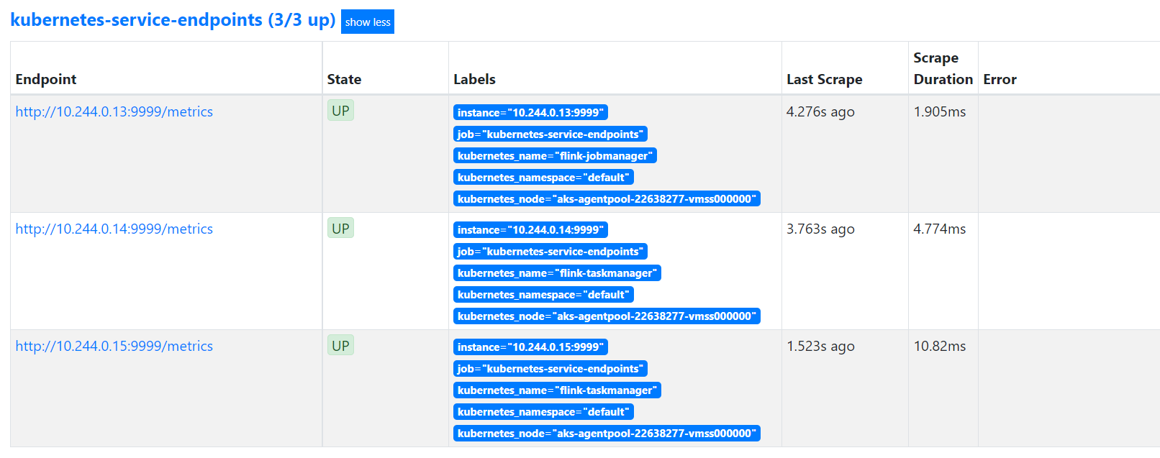

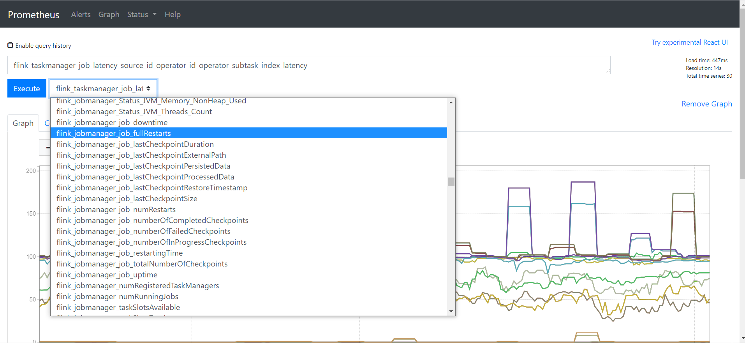

* Grafana

kubectl port-forward service/grafana 8080:3000

